CNS 1410 Object-oriented Programming

Programming Project 6: Temperature Conversion

Due Date:
Must be submitted no later than 1:00am next Monday.
Programs received prior to 1:00am on Sunday will receive 5 bonus points, if the program completely meets the specifications and executes correctly.

Objective:
- To give student's experience constructing a GUI application, using wxWidgets
- To help students understand event driven programming.

Background:
In this project, you will create a simple GUI application that converts Centigrade to fahrenheit, and vice versa. The formulas are
C = (F - 32) / 1.8
F = (C * 1.8) + 32

The Graphical User Interface
Your interface should consist of the following:
- A Frame, containing a menu bar. On the menu bar is a menu object labeled "File".
- The File Menu provides two options: "Exit", and "About".
- When "Exit" is chosen your program should terminate.
- When "About" is chosen, your program should display a message box containing your name and the text "Project 6".
- On the Frame, you should place a panel. Panels are used to lay out GUI components.
- On the panel you should have a text control into which the use can type a temperature in degrees Fahrenheit.
- Use a static Text control to label this field.
- To the right of this field, place a button labeled "to Centigrade".
- Below this field place a second text control into which the user can type a temperature in degrees Centigrade.
- Use a static text control to label this field.
- To the right of this second field place a button labeled "to Fahrenheit".
See the sample output below to see what your GUI should look like.

Program
The operation of this program is very simple. If the user types a value into the temperature field for Fahrenheit, and then clicks on the "to Centigrade" button, your program will read in the user's input, and convert the temperature to Centigrade. It will output this value in the temperature field for Centigrade.
Similarly, if the user types a value into the temperature field for Centigrade, and then clicks on the "to Fahrenheit" button, your program will read in the user's input, and convert the temperature to Fahrenheit. It will output this value in the temperature field for Fahrenheit.
Study the slides and the lab material carefully to understand how to lay out the user interface. There are also a number of wxWidgets examples on the course web site. The wxWidgets web site provides useful documentation on all of the wxWidgets components if you need it. This project may require you to spend some time experimenting to get everything looking and working right.

Hints
You can find soem hints for this project here.
Format and document your code in accordance with the course style guidelines. Include a file prologue identifying you as the author. Submit your project using the instructions outlined in the Course Syllabus, Programming Projects section.

File(s) to Submit:
All source code files and an executable file.

Grading
The Grade sheet is here

Sample Output:
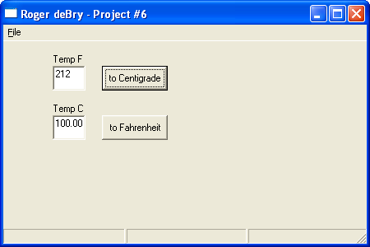

Sample Executable
The GUI Program

